Project Development phase Sprint-2

|  |  |
| --- | --- |
| Date | 8th November 2022 |
| Team ID | PNT2022TMID53935 |
| Project Name | Real-Time River Water Quality Monitoring and Control System |

**Design of web application using Node-Red**

Using Dashboard nodes for create UI(Web application):

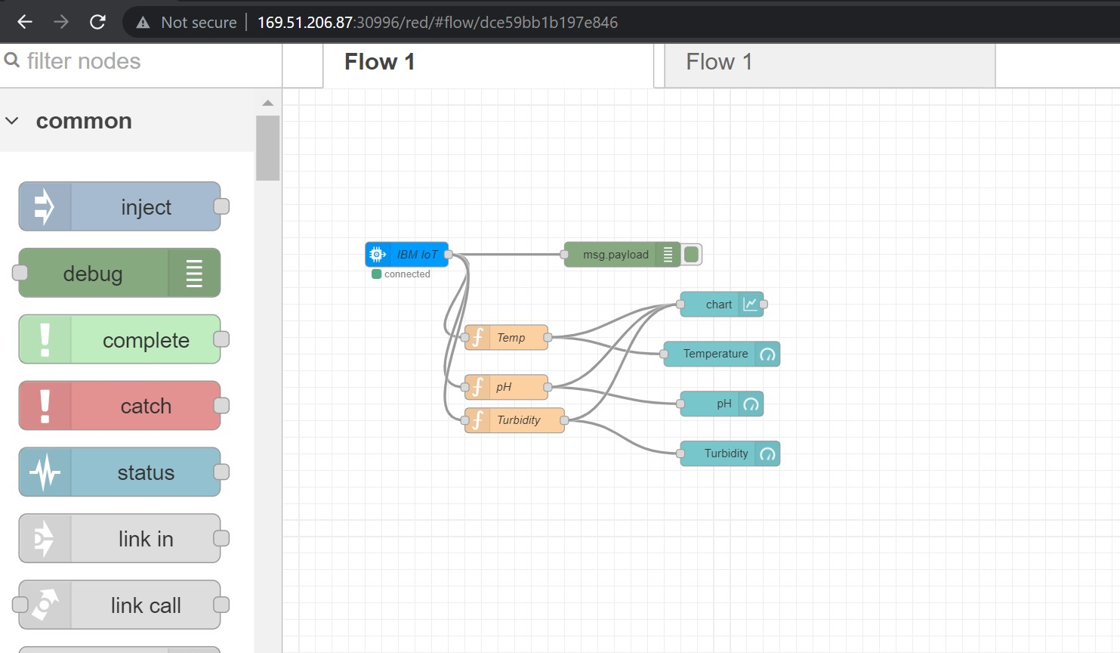

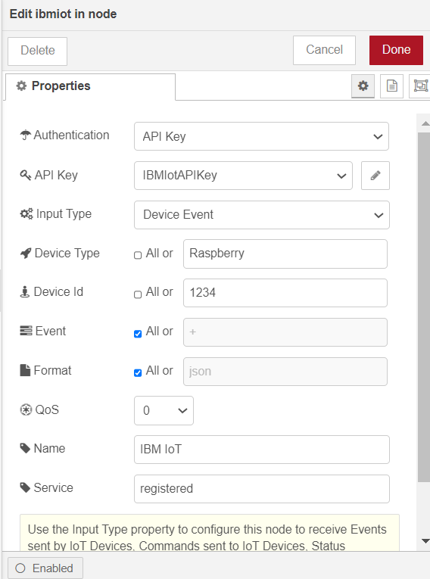

Debug Node output:

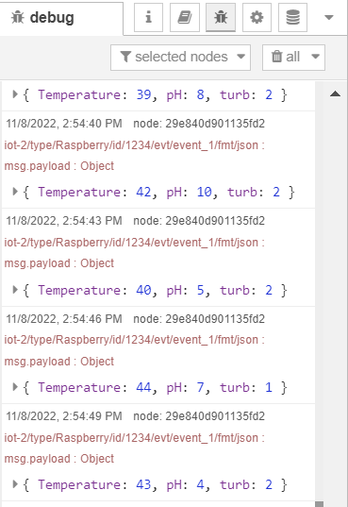

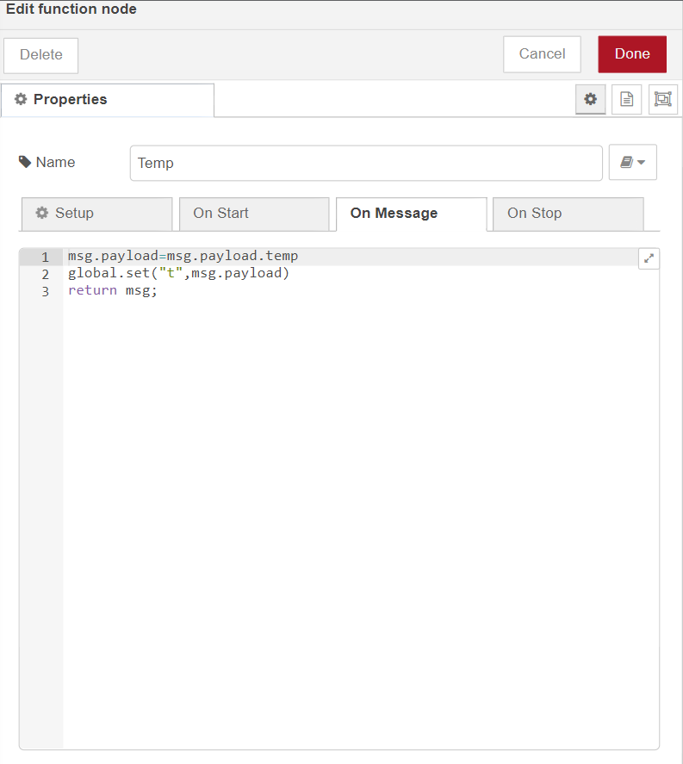

IBM Watson IoT Platform (Sensor readings stored in cloud):

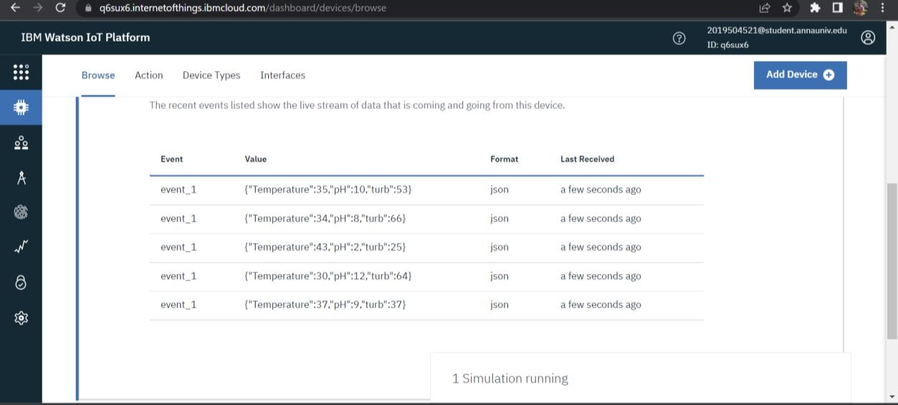

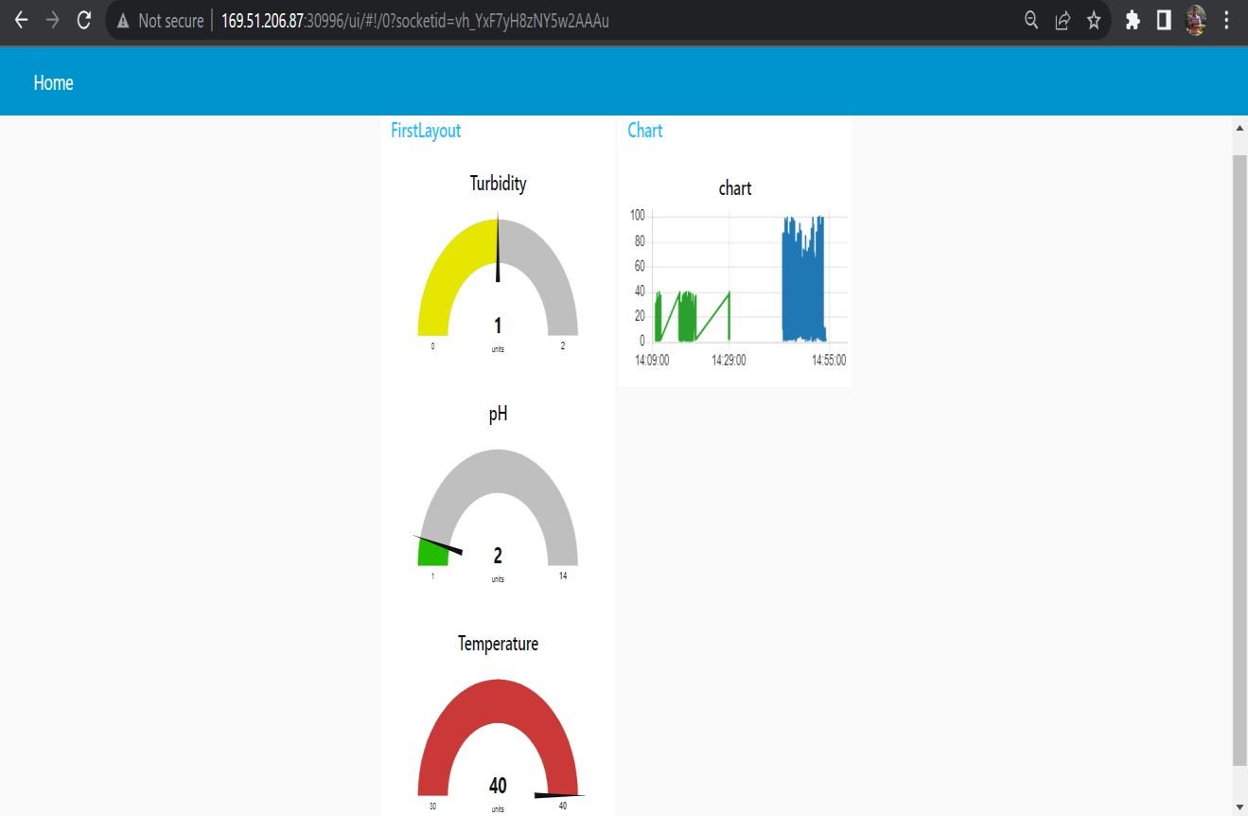

Web UI link: http://169.51.206.87:30996/ui/#!/0?socketid=p-TNVt- UhTDbqF2CAAAw